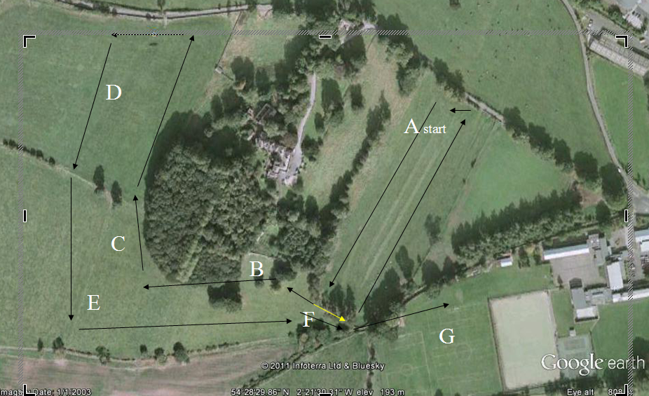

Minor boys and Junior girls. A.F.A x 2 ( 1 small laps) then one medium lap.3000m approx)

Minor girls. A.F.A.(1 SMALL LAP) THEN One full lap.(2000m approx)

Inter girls 2 full laps.(3000m approx)

Senior girls Junior boys. A.F.A. THEN 2 full laps( 3500m approx.)
Inter boys. A.F.A THEN 3 full laps.(5000m approx)

Senior boys. 4 full laps. (6000m approx)

